C02-ASSESSMENT TOOL -3
Coding Challenge
NAME: G. Sai Theja Sree
REG NO:192312175
Q1.
Write a MATLAB/Python program to perform image negative transformation on a grayscale image. Display the original and transformed images and explain the effect of the transformation.
OUTPUT:
The image negative transformation inverts the grayscale intensity values, making bright areas dark and dark areas bright, which enhances details in certain images.
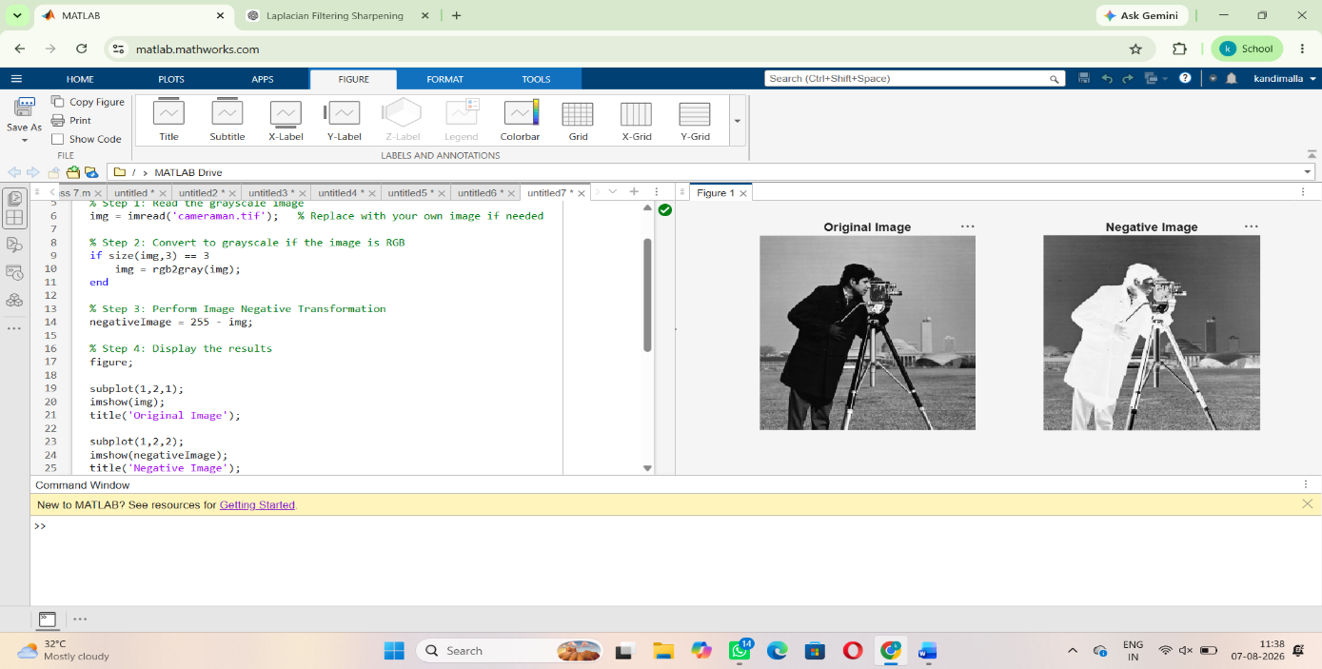
Q2.
Develop a program to perform histogram equalization on a low-contrast image. Plot the histograms before and after enhancement and interpret the improvement in image quality.
OUTPUT:
Histogram equalization improves image quality by spreading pixel intensity values over a wider range, resulting in better contrast and enhanced visibility of image details.
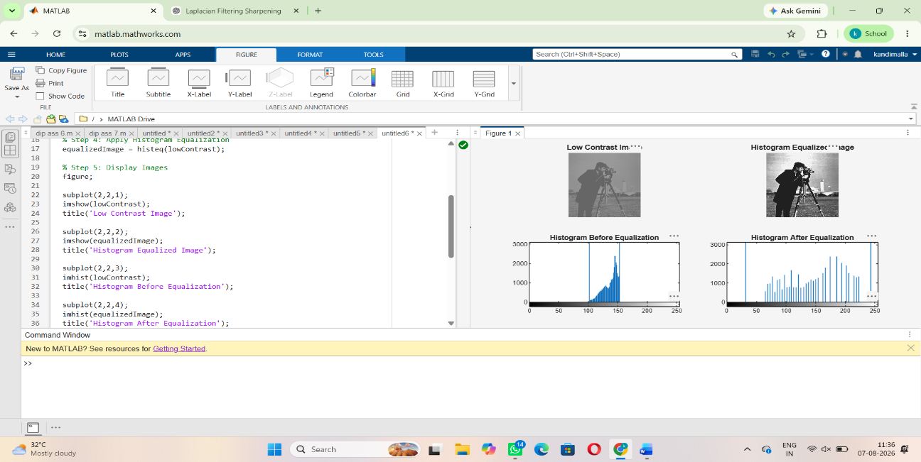
Q3.
Write a program to perform contrast stretching using gray-level transformation. Compare the enhanced image with the original image and discuss the changes in contrast.
OUTPUT:
Contrast stretching enhances the image by expanding the gray-level intensity range, producing better contrast and making details more visible than in the original image.
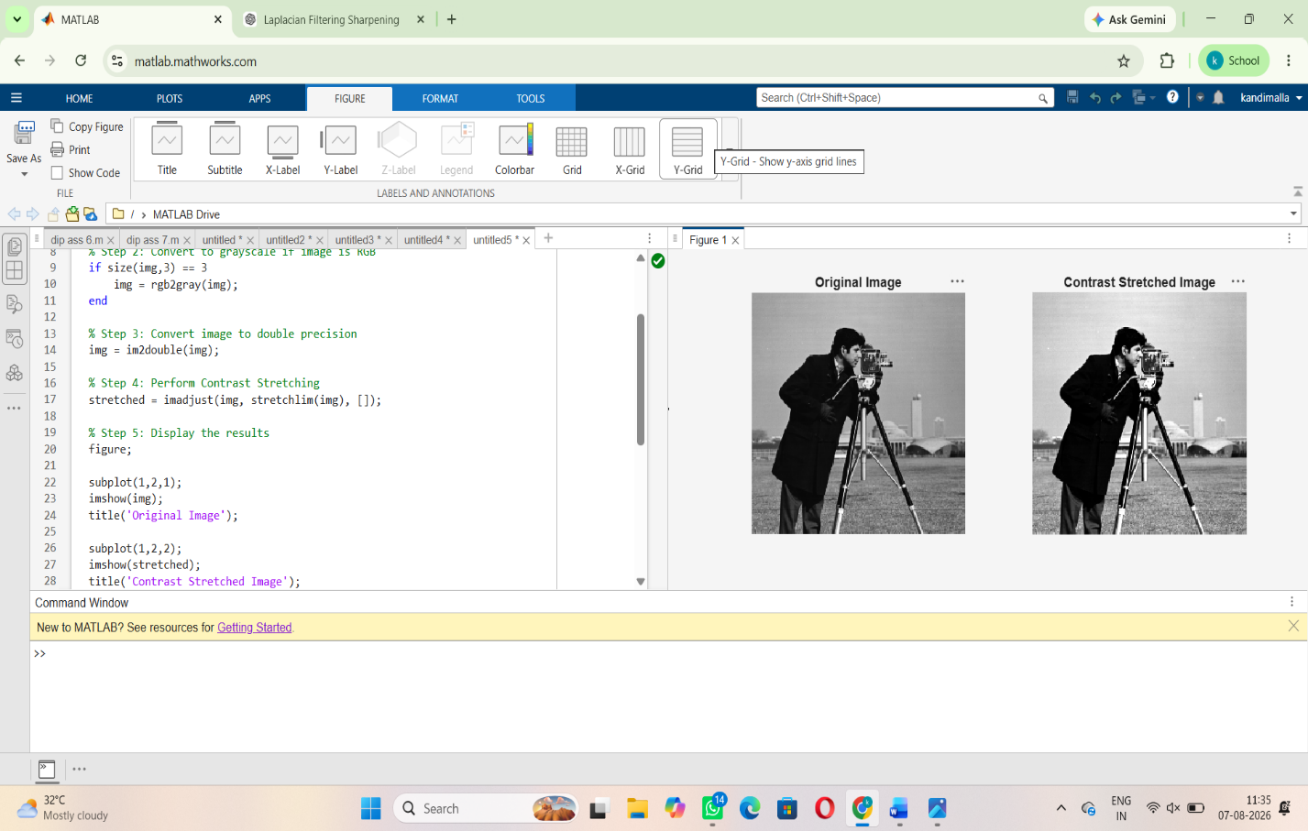
Q4.
Develop a MATLAB/Python program to implement a 3 × 3 Mean Filter for image smoothing. Compare the filtered image with the original noisy image and comment on the results.
OUTPUT:
The 3 × 3 Mean Filter reduces noise by averaging neighboring pixel values, producing a smoother image with slight loss of edge sharpness compared to the original noisy image.
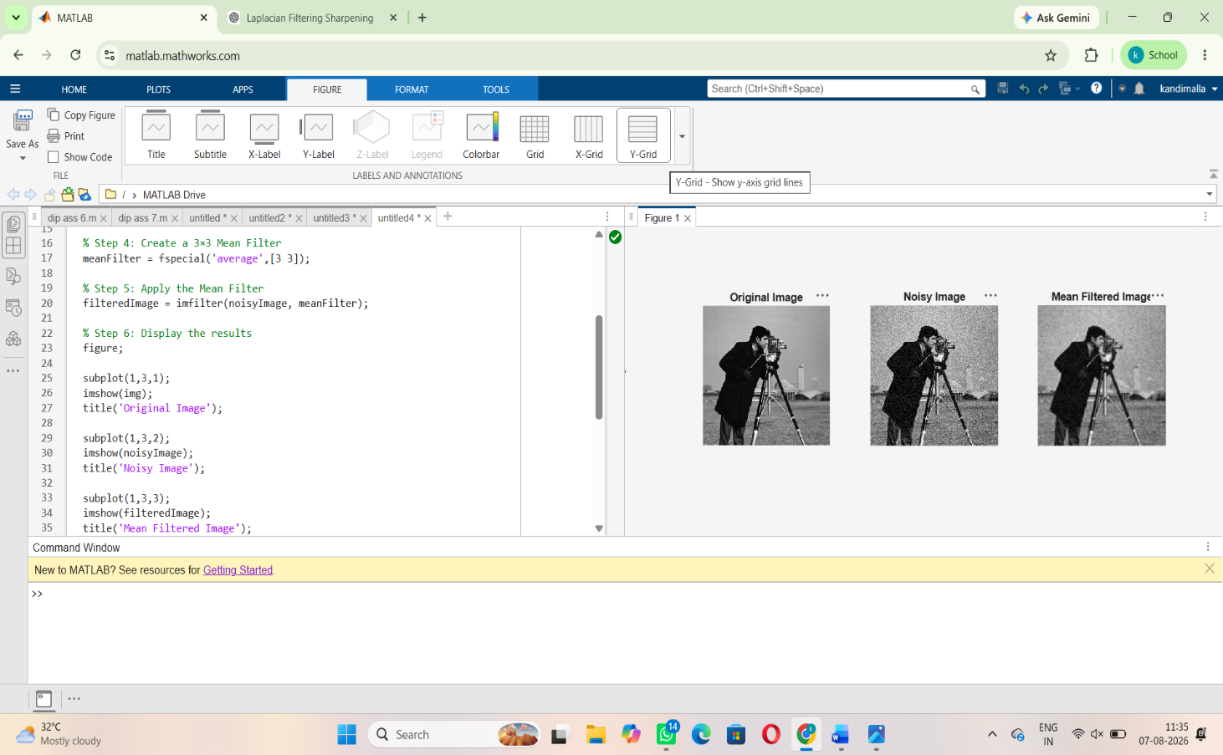
Q5.
Implement a Median Filter to remove salt-and-pepper noise from an image. Compare its performance with the Mean Filter and justify which filter is more suitable.
OUTPUT:
The Median Filter is more suitable than the Mean Filter for removing salt-and-pepper noise because it effectively eliminates impulse noise while preserving image edges and fine details.
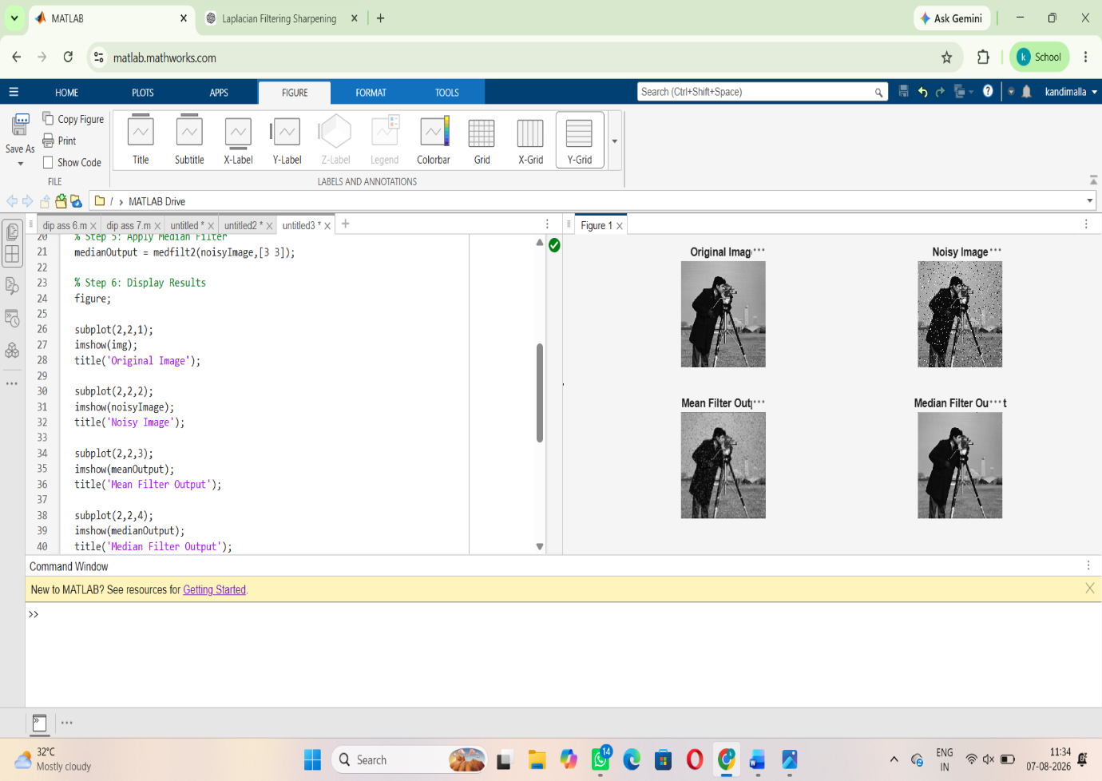
Q6.
Write a program to implement Laplacian Filtering for image sharpening. Display the sharpened image and explain how edge details are enhanced.
OUTPUT:
Laplacian filtering sharpens the image by enhancing edge details and highlighting regions with rapid intensity changes, making object boundaries clearer.

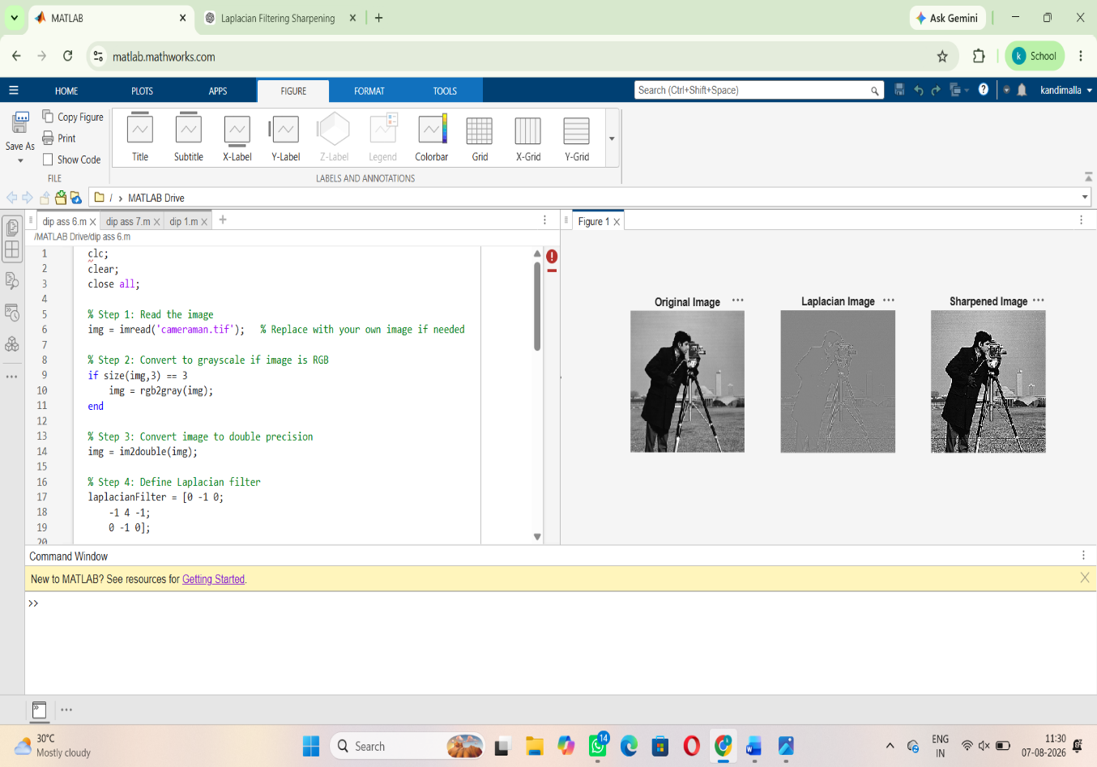
Q7.
Develop a MATLAB/Python program to compute the Two-Dimensional Discrete Fourier Transform (2D-DFT) of an image. Display the magnitude spectrum and explain its significance.
The 2D-DFT magnitude spectrum represents the frequency components of the image, where bright regions indicate dominant frequencies and help analyze image patterns, textures, and periodic structures.
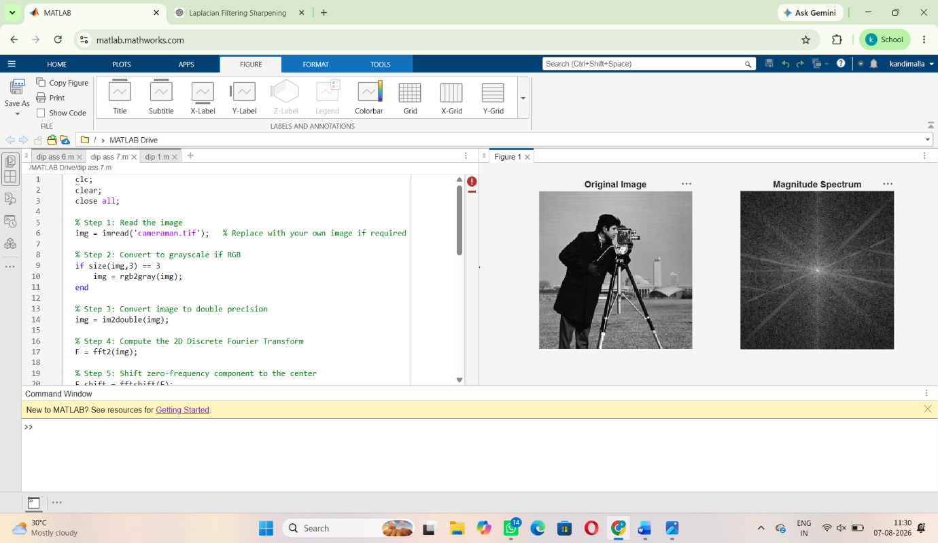
Q8.
Write a program to implement a Low-Pass Filter in the frequency domain. Display the original image, Fourier spectrum, filtered spectrum, and reconstructed image. Interpret the results.
OUTPUT:
The Low-Pass Filter smooths the image by removing high-frequency components such as noise and fine details.
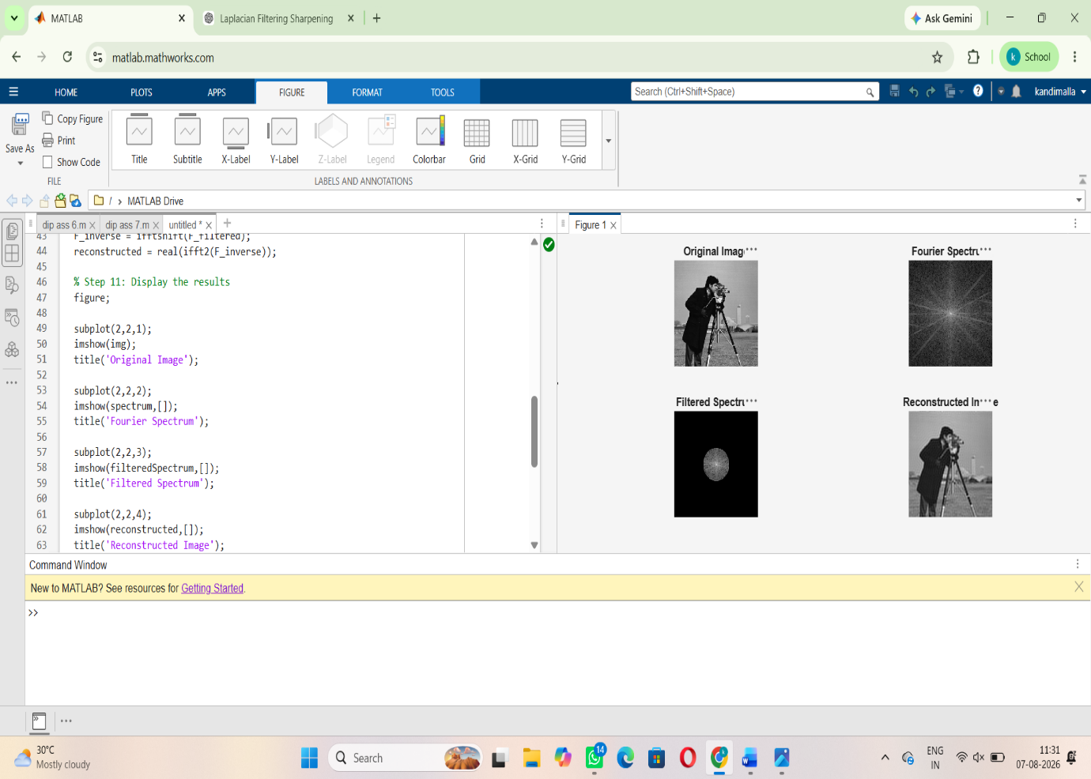
Q9.
Develop a MATLAB/Python program to implement a High-Pass Filter in the frequency domain for edge enhancement. Compare the output with the original image and discuss the observed changes.
OUTPUT:
The High-Pass Filter enhances edges by preserving high-frequency components, making image details and boundaries sharper than the original image.
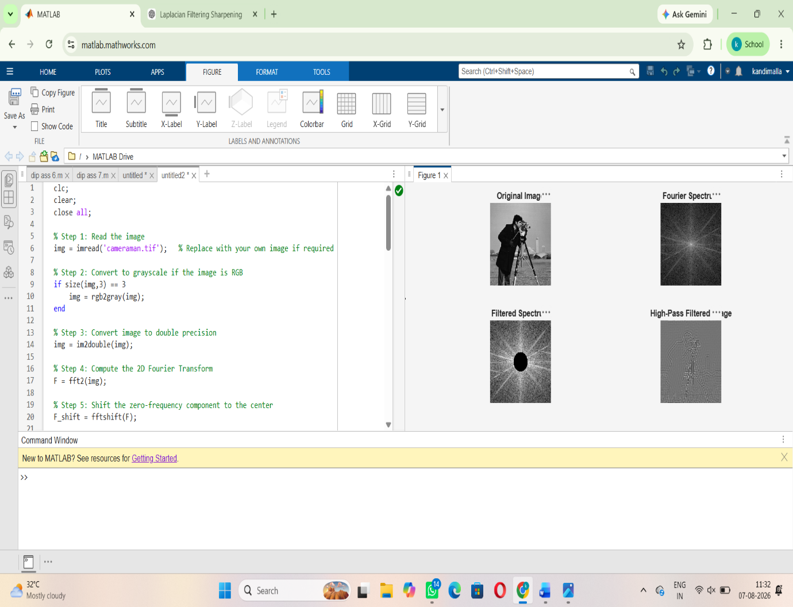
Q10.
A biomedical image contains low contrast and random noise. Develop a MATLAB/Python program to:
Enhance the image using histogram equalization. Apply an appropriate smoothing filter. Compare the original and processed images. Interpret the improvement achieved using suitable image quality observations.
OUTPUT:
- Read the Image: Load the biomedical image into MATLAB/Python for processing.
- Histogram Equalization: Improve the image contrast by redistributing the pixel intensity values.
- Smoothing Filter: Reduce random noise using a Gaussian or Median filter while preserving important image details.
- Display Images: Show the original and processed images side by side for visual comparison.
- Image Quality Observation: The processed image has better contrast, reduced noise, and clearer visibility of structures, making it easier to analyze.

